SPRINT 1
Introduction
High level programming language developed by GUIDO VAN ROSSUM in 1991.
Known for its:
- Readability
- Wide and strong library support
- Easier to understand
- Used in data science, automation, AI, web development and more
- Object oriented
- Dynamic typing

Libraries:
- Numpy: numerical computing, arrays, matrices, mathematical operations
- Pandas: data manipulation, cleaning, analysis, dataframes
- Polars: alt to pandas, used for fast dataframe/data processing alternatives to pandas
- Scipy: scientific computing, optimization, statistics, linear algebra
- Matplotlib: basic data visualization and plotting
- Beautfiful soup: web scraping and HTML parsing
- Pydantic: data validation and structured data models
- Tensorflow: deep learning & neural networks
- Opencv: computer vision

Frameworks:
- Django: full stack web development
- Flask: lightweight web backend
- Fastapi: high performance API development

Difference between library and framework
- Library: collection of pre written helper functions, you call it when u need it
- Framework: comprehensive skeletal structure or blueprint, provides the overall foundation for building an application, calls your code and enforces a way of doing things

Why python?
- Works on different platforms (windows, mac, linux, raspberry pi, etc)
- Simpler syntax
- Quick prototyping – runs on an interpreter system, code can be executed as soon as its written

IDEs – pycharm, vs code, pydev, jupyter ntbk, spyder, google colab, cursor, thonny, python idle, sublime text, mu

Relies on whitespaces for indentation, other languages use curly braces.

Comments
- Explains code
- Makes code more readable
- Use to prevent execution when testing code
- Created using: “#”
- Python ignores everything written after “#” atleast in the same line
- Multiline comments use: [“””] or [‘’’]

Unpacking - python allows to extract values from list/tuple into variables
List: []
Tuple: ()
Set: {}

Variables
- Anything that can change, vary, and is not fixed/constant.
- In cs, it’s a storage location in memory that holds a value which your program can change later.
- Python has no commands for declaring it
- Can get the data type of a variable with the type() function
- Strings can be declared using single/double quotes

Rules for Variable names:
- Must start with letter or underscore(_)
- Cannot start with number
- Can only contain alphanumeric characters
- Case sensitive
- Cannot be any of the keywords

Multi words variable names:
- Camel case: myVariableName
- Pascal case: MyVariableName
- Snake case: my_variable_name

Statements
- A program is a list of “instructions” to be “executed” by a computer
- These programming instructions are called statements
- Statement ends when line ends
- In python, semicolon(;) is not needed for that, unlikle some other languages
- Executed in the order they are written
- Syntactically legal(but unnecessary at most places), python treats it as a statement separator
- Writing 2 statements in a row w/o a separator will give an error

“print()” – used to display text or output values
Quotes – text to be written inside quotes, can use single (‘) or double(“) quotes both

By default, print() ends with a new line.
If want to print multiple words on same line use: “,end =‘ ’” inside print()

Global variables: created outside a function, can be used/accessed by anyone both inside and outside the function.

Local variables: created inside a function, can be ONLY used/accessed inside that function.

Keywords: total 39 (35 normal keywords + 4 soft keywords)

Global keyword: To set a local variable as global, use “global” keyword. We use it when we need to modify the value of a global variable inside a function.
! HOWEVER !, using the GLOBAL keyword will change the value for the entire program

Data Types
Core data types -> 4 (int , float, str, Boolean)
Total data types -> 12

Numeric : int, float, complex
Sequence: str, list, tuple, range
Mapping: dict
Set type: set, frozenset
Boolean: bool
None type: nonetype
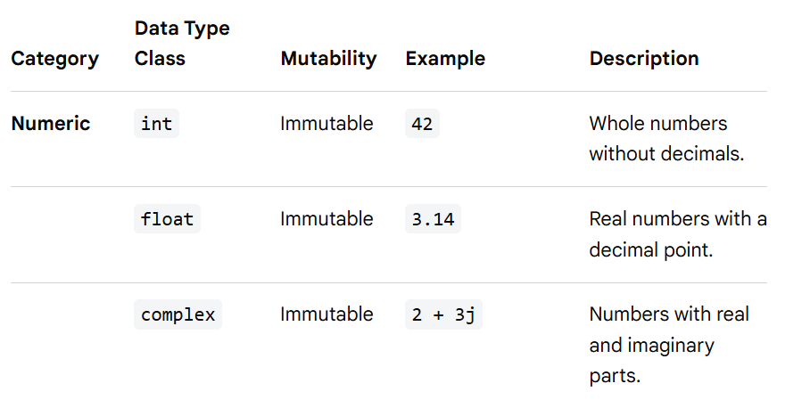
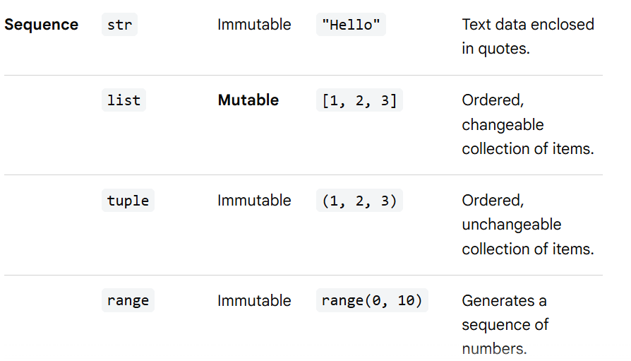
Unordered in older versions
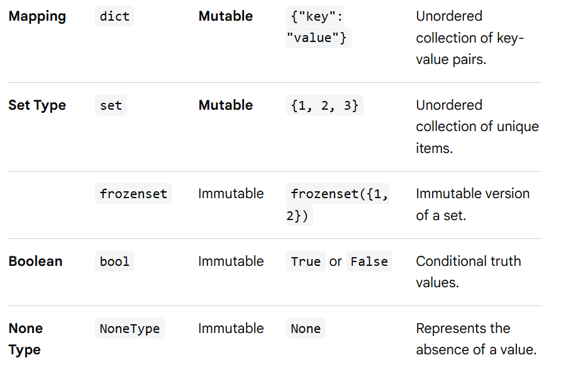
Type conversion
Can convert one type to another with int(), float(), complex() methods

Python has a built in module called random that can be used to make random numbers.

Object oriented language hence uses classes to define data types including its primitive datatypes.
Primitive : int, float, complex, bool, str, NoneType
Derived: list, tuple, set, frozenset, dict

Strings
- Surrounded by single/double quotation marks
- Arrays of unicode characters
- Square brackets are used to access elements(characters not words) of the string
- Length of string – len()
- “in” keyword to check if character/word present in a string
- “not in” keyword for the opposite purpose
- Slicing can be done as: var[start:stop:step]
- Some methods to modify strings: upper(), lower(), strip() -> removes white space,replace(), split()
- Concatenate: use “+”
- Can combine str and int using format() method
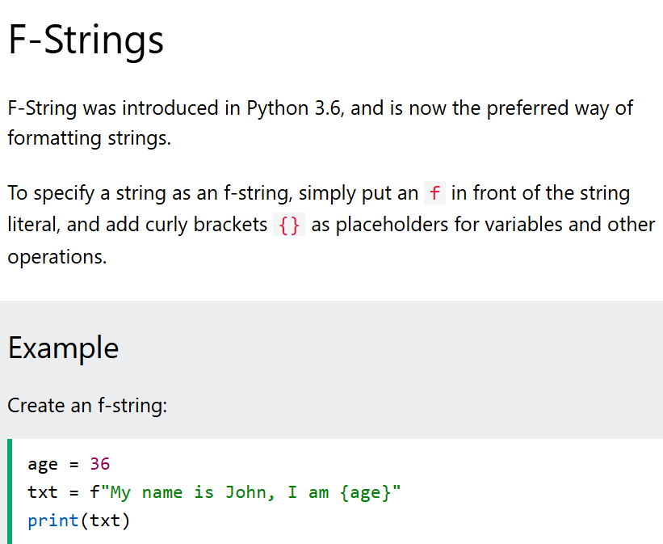
- Escape characters are used to insert the characters that are otherwise illegal, reserved, or difficult to type directly into a string literal
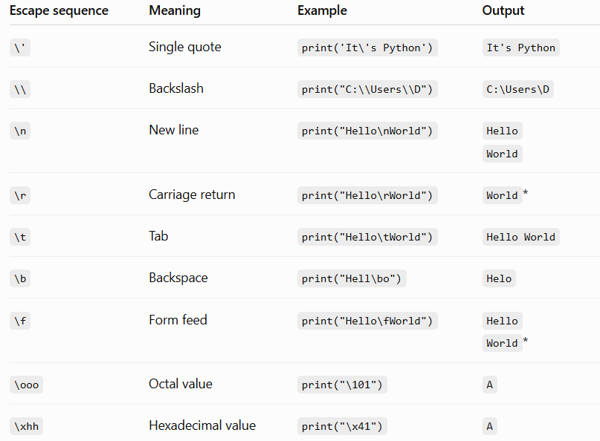
- String methods
Method | Description
capitalize() | Converts the first character to upper case
casefold() | Converts string into lower case
center() | Returns a centered string
count() | Returns the number of times a specified value occurs in a string
encode() | Returns an encoded version of the string
endswith() | Returns true if the string ends with the specified value
expandtabs() | Sets the tab size of the string
find() | Searches the string for a specified value and returns the position of where it was found
format() | Formats specified values in a string
format_map() | Formats specified values in a string
index() | Searches the string for a specified value and returns the position of where it was found
isalnum() | Returns True if all characters in the string are alphanumeric
isalpha() | Returns True if all characters in the string are in the alphabet
isascii() | Returns True if all characters in the string are ascii characters
isdecimal() | Returns True if all characters in the string are decimals
isdigit() | Returns True if all characters in the string are digits
isidentifier() | Returns True if the string is an identifier
islower() | Returns True if all characters in the string are lower case
isnumeric() | Returns True if all characters in the string are numeric
isprintable() | Returns True if all characters in the string are printable
isspace() | Returns True if all characters in the string are whitespaces
istitle() | Returns True if the string follows the rules of a title
isupper() | Returns True if all characters in the string are upper case
join() | Joins the elements of an iterable to the end of the string
ljust() | Returns a left justified version of the string
lower() | Converts a string into lower case
lstrip() | Returns a left trim version of the string
maketrans() | Returns a translation table to be used in translations
partition() | Returns a tuple where the string is parted into three parts
replace() | Returns a string where a specified value is replaced with a specified value
rfind() | Searches the string for a specified value and returns the last position of where it was found
rindex() | Searches the string for a specified value and returns the last position of where it was found
rjust() | Returns a right justified version of the string
rpartition() | Returns a tuple where the string is parted into three parts
rsplit() | Splits the string at the specified separator, and returns a list
rstrip() | Returns a right trim version of the string
split() | Splits the string at the specified separator, and returns a list
splitlines() | Splits the string at line breaks and returns a list
startswith() | Returns true if the string starts with the specified value
strip() | Returns a trimmed version of the string
swapcase() | Swaps cases, lower case becomes upper case and vice versa
title() | Converts the first character of each word to upper case
translate() | Returns a translated string
upper() | Converts a string into upper case
zfill() | Fills the string with a specified number of 0 values at the beginning

Boolean : True or False. Bool() function allows us to evaluate any value and give True/False in return

Operators: 9 types in python
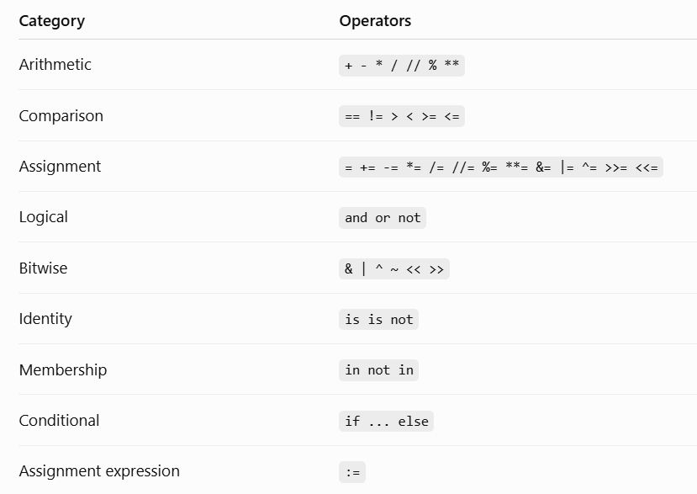
Walrus operator (:=) lets us assign a value to a variable and use the value immediately in the same expression.
Ternary operator ( conditional expression) is a 1 line alternative to traditional if-else statement
Value_if_true if condition else value_if_false

Difference between is and ==
Is – checks if both point to the same object in memory
== - checks if the values of both variables are equal

Bitwise operators used to compare binary numbers

Precedence order
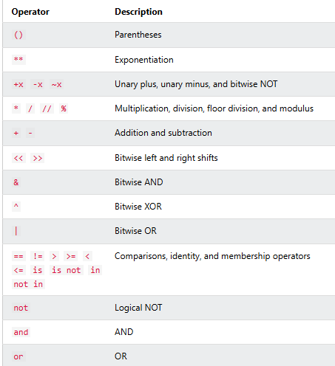

List
- Multiple items in single variable
- Ordered
- Mutable
- Allows duplicates
- [] brackets
- Accessed through index values
- List functions
- Len() – length of list
- Index() – returns index of the 1st occurrence of a specified value
- Insert() – inserts item at specified index # eg. x.insert(2,”apple”)
- Append() – adds item at the end of the list
- Extend() – appending elements from other list to current , can also be done using ‘+’ operator
- Removes() – removes specified item
- Pop() – removes item from specified index, if index not specified removes the last item by default
- Del() – removes the item at specified index
- Clear() – empties the list, but the list remains
- Sort() – sorts the list alphanumerically in ascending order by default, for descending, use “reverse = True”. Uppercase before lowecase. If need case insensitive sorting use key=str.lower
- Reverse() – order reversed irrespective of alphabetic sequence
- Copy() – copies 1 list into another, another way is list(), can also use x[:] (the slicing operator
- List comprehension : shortest way to loop through lists

Tuples
- indexed
- Ordered
- Immutable/unchangeable
- Allows duplicates
- Uses () brackets
- Cannot remove items from a tuple, still if needed:
- Tuple->list(remove item)->tuple
- Tuples can be deleted entirely
- Can also be created without parantheses
- Rest functions are same as that of list
- How to change tuple values?
- Tuple->list(update/change/add value)->tuple
- Can add 2 tuples together, and even multiply them (repetition)
- Packing: putting multiple values in a tuple
- Unpacking: taking out values from the tuple and assigning them to separate variables. “*” can be used when count(var)<count(elements(tuple)), it will print them all as a list

Sets
- Unindexed
- Unordered
- Unchangeable/immutable
- Duplicates not allowed
- Can remove/add items
- Uses {} brackets
- True is same as 1, False is same as 0 in sets hence only 1 of each pair gets printed(duplicate eliminated)
- Cannot access the values using index, as unordered(either use loop or use in/not in operator with the specific value)
- Add() – can add items to the set (gets added to the last)
- Update() – adds 1 set to another, can also add any iterable object to the set
- Remove() and discard() – both are used to remove elements from the set. Remove() raises error if that element doesn’t exist, discard() doesn’t.
- Pop() is used to remove item too, but we’re not sure what item will be removed – as sets are unordered
- Clear() – used to remove the values, set remains even if empty
- Del() – set is completely deleted
- Joining sets:
- Union() – combines both sets and returns new set ( original sets remain unchanged)
- Update() – adds elements from 1 set to another and returns the modified set (only the set to which other elements from different set are added, is modified)
- Intersection() – will only return the duplicate value/s, can also use (&) operator
- Intersection_update() – will return the duplicates but in the original(modified) set
- Difference() _ will return a new set that will have only unique elements from the 1st set which are not present in the other set, can also use the “-“ operator
- Difference_update() – will return the unique values in 1st set(which arent present in other) but in the original(modified) set
- Symmetric_difference() – will return a new set which has unique elements of both sets, can also use “^”
- Symmetric_difference_update() - will return an original set(modified) which has unique elements of both sets

Frozenset
- Immutable version of sets
- Unordered
- Unindexed
- Unchangeable
- Cannot even add/remove values from a frozenset
- Can create a copy of frozenset

Dictionary
- Ordered (Python 3.6 and earlier versions were unordered)
- Mutable
- Duplicates not allowed (unique keys, values can be duplicate)
- Stores data in key:value pairs
- Can access the items of a dictionary by referring to its key name as: dict1[“name”]. can also use get() method. Difference wil be that: get() method wont throw an error if a key doesn’t exist, whereas the regular method does
- Keys() – will return a list of all keys in a dictionary
- Values() – will return list of all values in a dictionary
- Items() – will return list of all items in a dictionary
- Update() – will update dictionary with the already existing key/s, or add a new key:value pair
- Pop() – removes the item with specified key name
- Popitem() – removes last inserted item
- Del() – removes specified item from dictionary

Difference between pop() and del()
Pop() removes a specified key and returns its value
Del() simply removes the key, without returning anything

- Clear() – empties the dictionary, but doesn’t delete it

Conditional Statements
- If…else (2 conditions)
- Elif (3 or more conditions) – better because it ignores the remaining conditions once the ‘true’ one is found
- Else – catches anything that isnt caught by the preceding conditions i.e. the conditions before it were ‘false’; provides a default action; comes at last
- Shorthand if – if only 1 statement to execute, can put it on the same line as the if statement, but still need the colon after it
- Shorthand if else – value_if_true if conditon else value_if_false, aka ternary operator/conditional expression

Logical Operators
- Used to combine conditional statements
- 3 logical operators: and, or, not
- And: returns true if both statements are true
- Or: returns true if one of the statements is true
- Not: reverses the result, returns false if the result is true
- Precedence: not->and->or
age =25
is_student = false
has_discount_code = true
Eg. : if(age<18 or age>65) and not is_student or has_discount_code

- Truth tables: understanding of how logical operators work with diff values
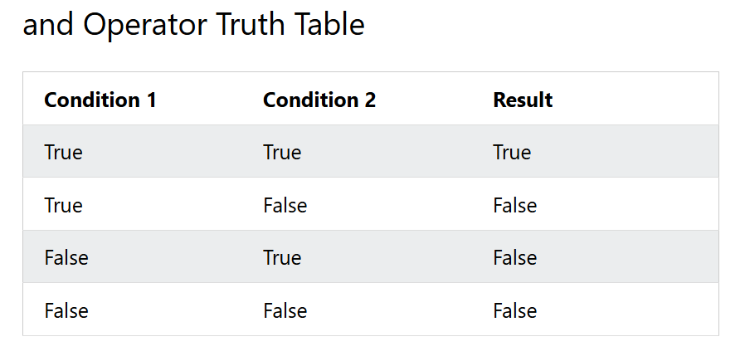
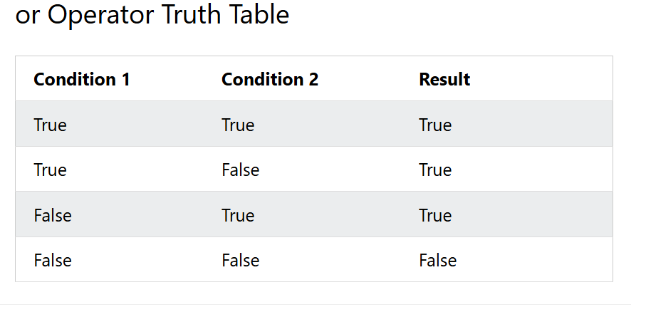
- Nested if – if statement inside another if statement.
Inner if statement only runs if the outer if condition is true.

Use as per need:
Nested if statement: when the second condition depends on the first to be true and we need true/false checks at multiple levels
Logical operators: when we need all the conditions to be true at the same time.
Compilation error:
Happens when computer program cannot translate source code into an executable file because the code breaks the rules or structure of the programming language

Match statement
Instead of writing many if…else statements, we can use the match statement
Match selects one of the many code blocks to be executed

Loops
- While – can execute statements as long as the condition is true; keep in mind to increment ‘i”, or the loop will execute forever.

- For – used for iterative over a sequence (list, tuple, dictionary, set, string).
Range() function in for loop is used to loop through a set of code a specified no of times. Must always specify an ending value, starting value as needed. Specifiying increment value by using a third parameter is optional as well.

** Else – with while & for statement, else can be used along with it once when the condition is no longer true/loop is finished. It will not be executed if the loop is stopped by a break statement.

Looping statements
- Break – skips the entire loop once when the condition is met(True)
- Continue – skips the current block of code but executes the remaining part of the loop
- Pass – when we need to write a statement syntactically and it cant be empty, we use “pass” to avoid getting an error ; or the part which we might want to change/update later ; is a null operation -> nothing happens when python executes it, serves as a placeholder.
Can be used with if-elif-else, while and for loops

Difference between pass and comments:
- Comments get ignored by python
- Pass is actual statement that gets executed

